STRENGTHENING SUPPLY CHAINS TO IMPROVE COMMODITY AVAILABILITY AT THE LAST MILE
Strategy Template for Reproductive, Maternal, Newborn, and Child Health Commodity Security, with a Focus on Building Resilience in Fragile Settings

December 2023

Submitted to:
United States Agency for International Development under
Cooperative Agreement # 7200AA20CA00005

Submitted by:
IMA World Health, with JSI Research & Training Institute, Inc.; Pathfinder International; Cooperative for Assistance and Relief Everywhere, Inc.; GOAL USA Fund; and the Africa Christian Health Associations Platform

This report is one in a series of three products presenting MIHR experiences with supply chains at the last mile.

Disclaimer
MOMENTUM Integrated Health Resilience is funded by the U.S. Agency for International Development (USAID) as part of the MOMENTUM suite of awards and implemented by IMA World Health (IMA) with partners JSI Research &Training Institute, Inc. (JSI), Pathfinder International, GOAL USA Fund, Cooperative for Assistance and Relief Everywhere, Inc. (CARE), and Africa Christian Health Associations Platform (ACHAP), along with Premise Data, Harvard T.H. Chan School of Public Health Department of Global Health and Population, Johns Hopkins Bloomberg School of Public Health Department of International Health, and Brigham Young University as resource partners, under USAID cooperative agreement #7200AA20CA00005. For more information about MOMENTUM, visit www.USAIDMomentum.org. The contents of this template document are the sole responsibility of IMA World Health and do not necessarily reflect the views of USAID or the United States Government.

Table of Contents

Strategy Template: Introduction iii
Begin Strategy Template iv
Sample Title Page 1
Foreword 2
Acknowledgments 3
Table of Contents 4
Abbreviations and Acronyms 5
Executive Summary 6
Introduction 7
Goal 9
Purpose 9
Strategy Development/Methodology 9
Background 11
[Country Name] Health System 11
Reproductive, Maternal, Newborn, and Child Health 11
Voluntary Family Planning 12
Supply Chain System 12
Strategy 13
Vision, Mission, Goals 13
1. Commitment 15
2. Coordination 17
3. Supply Chain Capacity 19
4. Capital/Financing 23
Strategy Implementation/Operational Plan 26
Monitoring and Evaluation 28
Suggested Revision of Results Indicators Table 29
Results Indicators 29
References 33
Appendix 1. Additional Resources 34
Appendix 2. RMNCH Country Strategies 36

Strategy Template: Introduction
Reproductive, maternal, newborn, and child health commodity security (RMNCH-CS) exists when every person can choose, obtain, and use quality reproductive, maternal, newborn, and child health commodities. The framework presented in this strategy, based on the reproductive health commodity security framework, provides a model for addressing the issues to create an enabling environment for commodity security. Many factors affect RMNCH-CS, from enabling government policies, the socioeconomic status of a country, the funding to purchase commodities, coordination efforts among all health actors, and the capacity of the supply chain to store and distribute commodities to the last mile.
Although many partners work on supply chain strengthening at the central or regional levels, in many countries the lowest levels of the health care system need additional attention and resources. A last mile commodity strategy can raise awareness about the importance of incorporating the lower levels and communities in supply-strengthening initiatives, as well as making supply chains in fragile settings more resilient. The supply chain, especially at the last mile, is often one of the first systems to break down and/or be mismanaged in times of crisis; a well-functioning supply chain system, especially at the last mile, is critical to emergency preparedness and mitigation of the negative impacts of future shocks and stresses. To provide continuity of services in fragile settings, the lower levels of a health system need to create support and build into their commodity management approaches positive redundancy, other simple cost-effective solutions, and contingency plans. Commodity security in fragile settings cannot be strengthened if preparations are not made to continue service and supply operations to build positive redundancy into the system. A commodity security strategy must also consider emergency preparedness, especially when working to build resilience at the last mile in fragile settings.
This strategy template serves as a starting point to develop an RMNCH-CS strategy, with attention on the last mile and additional examples of activities for emergency preparedness. Sample objectives and illustrative strategies and activities are provided as examples of various solutions to improve commodity availability. This template focuses on four areas: commitment, coordination, capacity, and financing. The strategies and activities can be integrated into an already-existing supply chain or commodity security strategy, or they can be the starting point to develop a full RMNCH-CS strategy incorporating all health system levels and the private sector. All of the text under each of the components and illustrative strategies, activities, and indicators should be adjusted and adapted to each country’s needs and context. Additional sections, such as service delivery and client demand and utilization, can be added as needed. Advice and prompts are presented in [brackets] and should be removed when adapting this template to a country’s needs.
Several country RHCS strategies can be found Appendix 2 as examples that countries can adapt and modify to address their challenges.
Begin Strategy Template
BEFORE USING THIS TEMPLATE, DELETE ALL PREVIOUS INSTRUCTIONAL PAGES, INCLUDING THIS PAGE.

Sample Title Page
[Insert title of RMNCHCS strategy and time period to be covered, per the example below]

REPRODUCTIVE, MATERNAL, NEWBORN, AND CHILD HEALTH
COMMODITY SECURITY STRATEGY AT THE LAST MILE

2024–202X

[Country] Ministry of XXX

Foreword
[To be written by Ministry]

Acknowledgments
[To be written by MOH]

Table of Contents
[Create table of contents here after deleting initial table of contents and introductory section above.]

Abbreviations and Acronyms
[Edit, delete, and revise this list to reflect terms actually used in the strategy]
ANC Antenatal care
ARV Anti-retroviral
CBD Community-based distribution
CHW Community primary health worker
CMS Central medical store
COC Combined oral contraceptive
CPR Contraceptive prevalence rate
DHS Demographic and Health Survey
EML Essential medicines list
EPI Expanded Program on Immunization
FEFO First expiry, first-out
FP Voluntary family planning
GFATM Global Fund to Fight AIDS, Tuberculosis & Malaria
HIV and AIDS Human immunodeficiency virus/acquired immune deficiency syndrome
HMIS Health management information system
IEC Information, education, and communication
IUD Intrauterine device
LMIS Logistics management information system
LSC Life-saving commodity
M&E Monitoring and evaluation
MMR Maternal mortality ratio
MNH Maternal and newborn health
MOF Ministry of Finance
MOH Ministry of Health
MOS Months of stock
MOU Memorandum of understanding
NGO Nongovernmental organization
POP Progesterone-only pills
RMNCH-CS Reproductive, maternal, newborn, and child health commodity security
SDP Service delivery point
SOP Standard operating procedures
STG Standard treatment guideline
STI Sexually transmitted infection
TB Tuberculosis
TFR Total fertility rate
TOR Terms of reference
TWG Technical working group
UNDP United Nations Development Program
UNFPA United Nations Population Fund
USAID United States Agency for International Development
WHO World Health Organization

Executive Summary
[Include the purpose and goal of the strategy, a summary of the key issues, and proposed solutions in the strategic plan. Up to 2-3 pages.]

Introduction
[Introduce the concept of RMNCH-CS, the JSI framework, and why it is important in the context of the health system, supply chain, and achieving national health goals. Illustrative text for adaptation:]
Reproductive, maternal, newborn, and child health commodity security (RMNCH-CS) exists when every person can choose, obtain, and use quality contraceptives and other voluntary family planning (FP), reproductive health (RH), and maternal, newborn, and child health (MNCH) commodities whenever she or he needs them. This means that commodities are both available and accessible at all health facility types and communities. The ability to choose means there must be an appropriate range of products available—i.e., the method mix, commodity availability, and appropriate information—so that clients can use the products correctly. To achieve RMNCH-CS, several elements are essential to establishing a supportive environment, including government and development partner support, generation of awareness and demand, mobilization of resources, and development of in-country capacity to ensure access to and availability of commodities and services. Recent global events and pandemics have shown the need for the health system and its staff to be ready during periods of disruptions. This requires planning for future events, to minimize commodity shortages and stockouts.
OPTION 1:
Figure 1. [with focus on supply chain capacity] Strategic Pathway to RMNCH-CS Framework
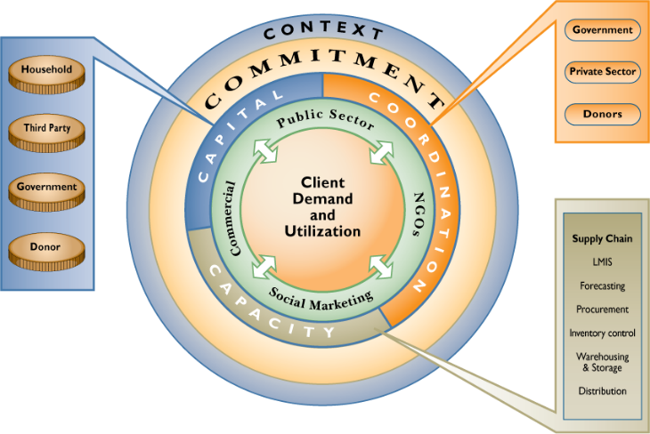
Source: JSI

OPTION 2:
Figure 2. [with focus on supply chain, service delivery capacity, etc.] Strategic Pathway to RMNCH-CS Framework
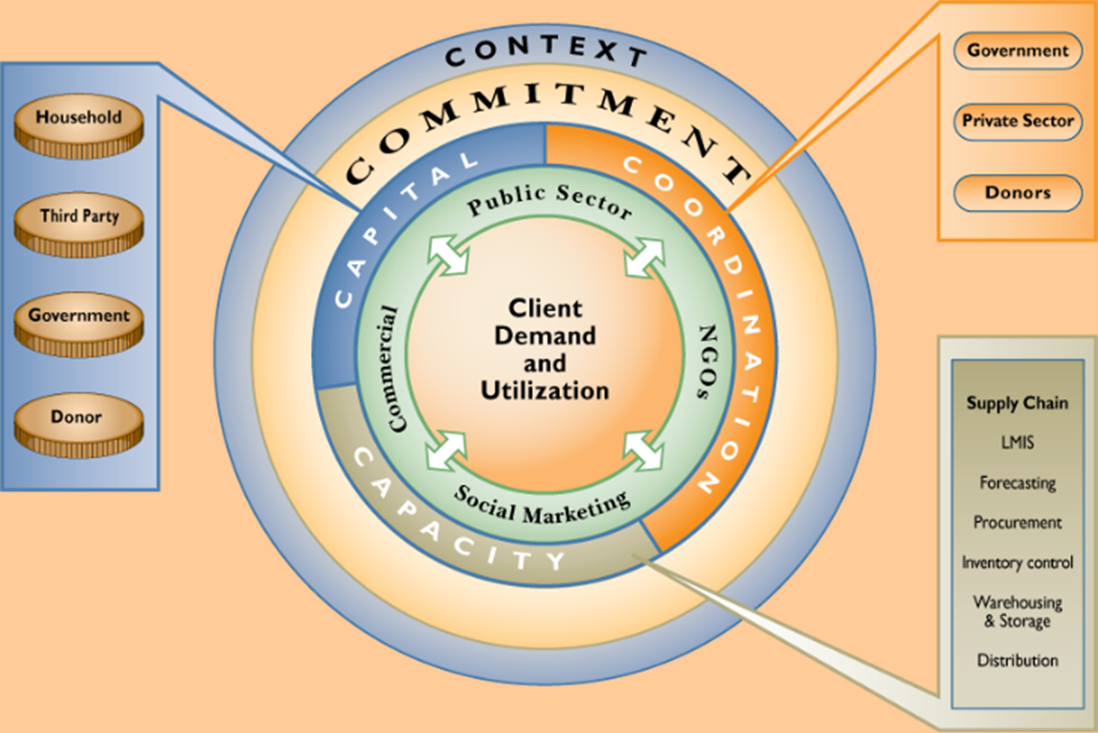
Source: JSI
The framework shown here provides a holistic view of the different components that influence a client’s ability to obtain and use health commodities. These elements are shown as interlinking rings of the circle in Figure X (above).
Figure X depicts how six essential RMNCH-CS elements impact client demand and utilization of commodities. In every country, there is a context that affects the country’s prospects for achieving RMNCH-CS, including national policies and regulations bearing on RMNCH—particularly on the availability of supplies—and broader factors such as social and economic conditions, political and religious concerns, and competing priorities. Within this context, commitment (evidenced in part by supportive policies, government leadership, and focused advocacy) is a fundamental underpinning for RMNCH-CS. It is the basis from which stakeholders invest the necessary capital (financing), coordinate for RMNCH-CS, and develop necessary capacities to ensure RMNCH-CS. The boxes in the figure elaborate on each of these three components. Coordination involves government, the private sector, and donors ensuring the effective allocation of resources. Households, third parties (e.g., employers and insurers), governments, and donors are all potential sources of capital. Additionally, capacities must exist for a range of functions, including the supply chain, demand generation, service delivery, supervision, and monitoring and evaluation. Clients (youth, women, and men) are the ultimate beneficiaries of RMNCH-CS as product users and, as shown by the double headed arrows, are also the drivers of the system through their demand.

Goal
[Illustrative text for adaption: ]
The goal of this Strategy is to ensure that every woman and man in [COUNTRY NAME] can choose, obtain, and use quality contraceptives and other vital RMNCH commodities whenever she or he needs them.
Purpose
[Illustrative text for adaption: ]
The purpose of this Strategy is to identify the critical needs and specify the interventions required to ensure continual availability of contraceptives and essential RMNCH and nutrition commodities at all health service delivery and commodity distribution points. The strategy can also emphasize the importance of developing preparedness plans to respond to emergencies and lay out a plan to begin coordination efforts with emergency teams, supply chain committees, and other relevant groups. This Strategy is designed to complement the enabling [national RMNCH policies/other policies/strategies] in [COUNTRY NAME] and to support other national health strategies and plans to provide a supportive framework for reproductive health (RMNCH) for women, men, and young people, including:
[Policy name]
[Policy name]
[Policy name]
Strategy Development/Methodology
[Summarize steps taken that led to the development of the Strategy, the objectives of the RMNCH-CS assessment, and the decisions agreed upon. Illustrative text for adaptation:]
The process of developing this RMNCH-CS Strategy began in [MONTH YEAR] with [insert assessments, field visits, awareness building and dissemination workshops, meetings, coordination and collaborations, desk reviews, surveys, consultancies, etc.].
The methodology used for the development of this strategic plan is based on the RMNCH-CS framework (see Figure X), one of the internationally tested tools for assessing and strengthening commodity security and health commodity logistics systems. The assessment served as a forum to spread awareness and develop a better understanding of and familiarity with RMNCH among government staff, health workers, implementing partners, nongovernmental organizations (NGOs), and the private sector.
Vital/essential reproductive health and contraceptives commodities.
[To help focus the RMNCH-CS on the most essential commodities, two example lists are provided below that can be adapted and merged as desired.]
For this Strategy, the following commodities have been designated as vital to reducing maternal and newborn mortality and morbidity in [COUNTRY NAME]. This list was agreed upon by the [NAME OF STAKEHOLDERS/COMMITTEE] and was adapted from a recommended list of vital and priority RH drugs that was developed by the United Nations Population Fund (UNFPA) and the World Health Organization (WHO).
Table 1. Essential Lifesaving Commodities and Contraceptives
Essential RMNCH Drugs | Contraceptives
Magnesium sulfate | Combined oral contraceptive pills (COCs)
Oxytocin | Progesterone-only pills (POPs)
Ergometrine | Injectable hormonal contraceptives
Iron/folate | Intrauterine devices (IUDs)
Amoxicillin | Implants
Azithromycin | Male condoms
Clotrimazole | Female condoms
Metronidazole | Emergency contraceptive pills
Benzathine benzylpenicillin | Cycle beads
Cefixime
Erythromycin
[Optional list of commodities: Illustrative text:]
A set of commodities should be available for health workers to provide or administer to clients at the primary health care level. The RMNCH-CS strategy is focused on a set of 13 overlooked life‐saving commodities (LSCs) identified by the UN Commission on Life‐Saving Commodities for Women and Children (Table X). If these commodities were more widely available, accessed, and properly used, they could save millions of lives and make a significant impact toward the achievement of the Sustainable Development Goals.
Table 2. Commodities Endorsed by the UN Commission on Life-Saving Commodities for Women and Children
Commodity, by Life Stage | Purpose | Examples of Key Barriers | Potential 5-Year Impact
Maternal health commodities
- Oxytocin | Postpartum hemorrhage | Often poor quality | 15,000 maternal lives saved
- Misoprostol | Postpartum hemorrhage | Not included in national essential medicine lists | 15,000 maternal lives saved
- Magnesium sulfate | Eclampsia and severe pre-eclampsia | Lack of demand by health workers | 55,000 maternal lives saved
Newborn health commodities
- Injectable antibiotics | Newborn sepsis | Poor compliance by health workers | 1.22 million neonatal lives saved
- Antenatal corticosteroids | Preterm respiratory distress syndrome | Low awareness of product and impact | 466,000 neonatal lives saved
- Chlorhexidine | Newborn cord care | Limited awareness and demand | 422,000 neonatal lives saved
- Resuscitation devices | Newborn asphyxia | Requires trained health workers | 336,000 neonatal lives saved
Child health commodities
- Amoxicillin | Pneumonia | Limited availability of child-friendly product | 1.56 million lives saved
- Oral rehydration salts | Diarrhea | Poor understanding of products by mothers/ caregivers | 1.89 million lives saved
- Zinc | Diarrhea | Poor understanding of products by mothers/ caregivers | 1.89 million lives saved
RH commodities
- Female condoms | FP/ contraception | Low awareness among women and health workers | Almost 230,000 maternal deaths averted
- Contraceptive implants | FP/ contraception | High cost | Almost 230,000 maternal deaths averted
- Emergency contraception | FP/ contraception | Low awareness among women | Almost 230,000 maternal deaths averted
Background
[Country Name] Health System
[If desired, provide a summary and background on the health system, which can include:
- Entities responsible for providing health care to the population.
- The structure/levels; include organograms, graphics.
- Reforms, initiatives.
- Sustainable Development Goals (SDGs).
- Actors supporting the health system—NGOs, donors, implementing partners.
- How rural, last mile, and hard-to-reach populations access health care.
- The role of community health workers (CHWs) and midwives.
- Supply chain lessons learned from COVID-19, Ebola, and other outbreaks and emergencies.
- Cost-recovery systems.]
Reproductive, Maternal, Newborn, and Child Health
[Information and statistics may include:
- Goals, achievements, challenges.
- Maternal mortality rate.
- Infant and child mortality rates.
- Demographic and Health Survey (DHS) data.
- Social, behavioral, and economic barriers to seeking or accessing care.]
Voluntary Family Planning
[Information and statistics may include:
- Goals, achievements, challenges.
- Total fertility rate (TFR).
- Contraceptive prevalence rate (CPR).
- Through DHS and Multiple Indicator Cluster Surveys (MICS), method mix, unmet need, source of contraception, future use, etc.
- Social, behavioral, and economic barriers to seeking or accessing care.]
Supply Chain System
[Information may include:
- A brief history, achievements, challenges.
- Structure, configuration, with a graphic of the product and information flows.
- Inventory parameters.
- Distribution structure, schedule, who is responsible for delivery or pick-up.
- Inventory management.
- Logistics management information system (LMIS).]
Figure 3. The Logistics Cycle
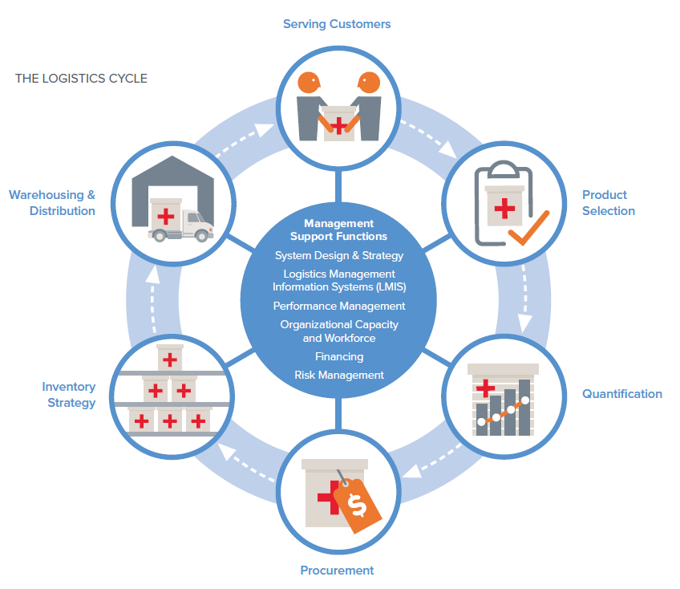
Source: JSI, 2020
Strategy
Vision, Mission, Goals
[Illustrative text for adaptation:]
The RMNCH-CS strategy supports national RMNCH programs to improve the lives of everyone who seeks FP and RMNCH products and services. It seeks to make FP and RMNCH commodities and services available down to the last-mile health facility and ensure access to all who need them.
Vision: To ensure RMNCH commodity security in all public and private health facilities.
Mission: To reduce unplanned fertility and maternal and child mortality and contribute to achieving the set of national and global targets.
Goal: To outline strategies to meet the increasing demand for FP and RMNCH commodities through increased commitment, coordination, supply chain capacity, and financing for commodity security.
[Additional content to include]:
- The National RMNCH-CS Strategic Plan supports the goal of the National Reproductive Health and Maternal and Child Health strategies. It provides the framework for actions and guidance for national and local initiatives aimed at ensuring the availability of and access to a full range of sexual and reproductive, maternal, newborn, and child health commodities and quality services for all [COUNTRY POPULATION], to enable them to attain optimal sexual, reproductive, maternal, newborn, and child health and well-being throughout their life cycle.
- The RMNCH-CS strategic plan activities are to help achieve the targets in the National RH and MNCH strategies [or name other policies, i.e., Sustainable Development Goals.]
- To increase modern CPR [or mention specific methods] by xx percent by [year].
Specific Components and Corresponding Objectives
This strategy presents [insert number of components] components, that, if achieved, will significantly improve RMNCH-CS. The XX-year strategic operational plan identifies strategies and priority activities for achieving the following specific objectives:
- Commitment: The policy environment at the national, county, and local levels sustains and supports the objectives of this strategy.
- Coordination: Strong coordination and partnership exist at all levels, and between all stakeholders and sectors, for the delivery of RMNCH services.
- Capacity: An effective and efficient supply chain exists for contraceptives and essential FP/RH commodities that ensures the availability of products to all people who need them throughout the country.
- Capital/Financing: Financing for the delivery of contraceptive and RMNCH products and services and related health promotion services is sustainable and equitable.
- Service delivery: Providers have the skills and materials necessary to satisfy client needs and demands.
- Demand: Clients have the information required to access the RMNCH and FP services and supplies they need.
Each component includes the following sections:
- Objective
- Strategies and corresponding activities
- Outcomes
- Indicators

- Commitment
[Illustrative text for adaptation: ]
Objective: To solidify commitment among all stakeholders at the national, state/district/county, and community levels to develop or strengthen supportive policies and strategies for RMNCH-CS at the last mile.
Situation: [Describe the current RMNCH and FP environment and context around:]
- Supportive policies.
- Government leadership.
- Focused RMNCH and FP advocacy.
- Support from development partners, nongovernmental agencies, faith-based organizations, and the private sector.
Illustrative information can also include:
- Describe supportive RMNCH and FP policies, strategies, programs, initiatives, advocacy campaigns or groups.
- Describe funding allocated to RMNCH and FP programs and commodities.
- Are there policy barriers to accessing contraceptives or certain RMNCH commodities?
- Are policies finalized and adhered to?
- Are there formal policies or guidelines on:
  - CHW roles and responsibilities, as well as provision of monetary or other compensation for their time and service?
  - Emergency preparedness procedures and guidelines at the last mile or at other levels of the health system?
- Are standard treatment guidelines or essential medicines lists up to date and available at health facilities?
Challenges: [List the current challenges. Illustrative examples:]
- RMNCH policies and strategies are not supported with adequate funding and budget.
- Primary health workers lack clear guidance for maintaining a reliable source of RMNCH and FP commodities during emergencies or periods of conflict.
- RMNCH policy and strategic documents are not distributed to the lower levels.
- Rural health facilities experience frequent product stockouts.
Strategies and activities: [Develop the strategies to address the challenges and the activities to achieve the strategy. Illustrative examples: ]
Strategy 1.1: Adapt existing strategies to include emergency preparedness guidelines and policies at the health facility and community level, so that formalized procedures across the country ensure commodity availability during emergencies.
- Form working group to include individuals from logistics teams, central medical stores, RMNCH and FP departments, and partners to draft emergency preparedness procedures with standard operating procedures (SOPs) and checklists for implementation at the last mile by primary health workers and CHWs.
- Incorporate language into relevant documents to operationalize procedures.
- Compile and conduct desk reviews of health-related policies, strategies, and guidelines and interviews with relevant personnel, to review current content related to addressing commodity security during emergency situations.
- Have a technical working group (TWG) create a dissemination and training plan to ensure awareness and comprehension of new emergency procedures to ensure continued flow of RMNCH and FP commodities during emergency periods.
Strategy 1.2: Strengthen distribution coordination among RMNCH partner and other health areas.
- Have the TWG identify where parallel supply chains—i.e., for antiretrovirals (ARVs), vaccines, and other essential medicines—can be leveraged during emergencies.
- Create formal procedures and incorporate them into existing policies and strategies.
- Create formal guidelines for making the availability of RMNCH and contraceptive commodities and supplies a priority in the country’s existing emergency preparedness activities.
Additional illustrative strategies:
- Adapt the existing RMNCH policy and strategies, particularly the FP component, to the current situation.
- Increase advocacy for RMNCH and FP at all political levels.
- Improve the policy and regulatory environment, which contributes to the enhancement of RMNCH and FP.
- Ensure that the commercial sector provides clients with safe and affordable quality RMNCH and FP products and services.
- Define and outline the scope and responsibilities of NGOs or CHWs in providing RMNCH and FP services in collaboration with the public sector.
Outcomes:
- Clear guidelines and procedures to mitigate commodity stockouts and shortages during emergencies.
- Strengthened partnerships and coordination among ministry departments, central medical stores (CMS), and emergency partners to jointly resolve supply chain issues during emergencies.
- Increased awareness among primary health workers and supervisors regarding emergency procedures.
Indicators:
- Meeting notes with actions and next steps from RMNCH and FP or similar committee.
- Supply Chain Emergency Preparedness TWG created
- Emergency procedures chapter, SOPs, and checklists are incorporated into existing policies and strategies.
- Emergency plan disseminated.
- Coordination
[Illustrative text for adaptation:]
Objective: To strengthen supply chain collaboration and coordination mechanisms to address emergency situations among all levels and relevant actors.
Situation: [Describe the current environment and context around:]
- Effective partnership between government, the private sector, and donors.
- Effective coordination and communication between and within national, state/district/county, and community levels.
- National policies and regulations.
- Social and economic conditions.
- Political and religious concerns.
- Competing public priorities.
Illustrative information can also include:
- What existing coordinating bodies and committees currently exist for logistics or commodities?
- How is coordination between the MOH and each level of the health system and CMS (including regional/district/state storage hubs, if they exist)?
- Are their mandates clear, how often do they meet, and are the members representative?
- What is the working relationship among RMNCH, FP, pharmaceutical units, CMS, NGOs, international partners, with respect to RMNCH?
- Are all partners, including civil society, involved in RMNCH coordination platforms and in RMNCH-related decision-making sessions?
Challenges: [List the current challenges. Illustrative examples:]
- Is coordination between the public and private sectors lacking? Where else is coordination lacking?
- There is a need to improve the coordination for supply chain issues within the MOH, especially between the central and district levels.
- Increased coordination of donors is needed.
- Greater coordination is required to ensure that new products are added to the essential medicines list and supply chain, as needed.
Strategies and activities: [Develop strategies to address the challenges and activities to achieve the strategy. Illustrative examples:]
Strategy 2.1: Create relevant supply chain–related coordination committees that serve as a decision-making body to leverage resources, share information, and find additional collaboration opportunities.
- [Example committee titles:] Logistics Committee or Drugs and Medical Supplies Technical Working Group, composed of MOH Planning Unit, Pharmacy Units, CMS and donors (logistics clusters, World Bank, UNFPA, UNICEF, USAID). Chaired by the MOH.
- Contact other country MOHs and partners to solicit lessons learned and obtain draft terms of reference (TORs) to adapt to their situation.
- Draft TORs for the coordination committees that include language and responsibilities during emergencies.
Strategy 2.2: Strengthen existing coordination mechanisms among the MOH, procurement partners, and other partners to ensure a continuous supply of commodities.
- Hire and place a full-time RMNCH Coordinator at the MOH to support and monitor RMNCH activities.
- Review resources and various lists of RMNCH and FP products and determine, in consensus with decision-makers, the ranges (upper and lower thresholds) of RMNCH and FP products to be maintained during emergencies.
- Establish semi-annual meetings of the county/state/district RMNCH supervisors for regular RMNCH and FP program monitoring and experience-sharing on supply chain operational issues and service delivery challenges.
- Develop relationships with suppliers and establish credits and standby agreements with back-up suppliers for priority products.
Additional illustrative strategies:
- Coordinate all activities related to RMNCH and FP service provision, supply chain, and health promotion, including training in these skills.
- Strengthen public-private partnerships for creating a conducive environment for the private sector’s engagement on RMNCH issues.
- Establish and/or strengthen RMNCH coordinating mechanisms at the county level.
Outcomes:
- Strong and effective supply chain committees or logistics coordination mechanisms are established with clear TORs.
- Communication and collaboration among MOH, (e.g., Ethiopian Pharmaceutical Supply Service, Ethiopian Food and Drug Authority), etc. are strengthened.
Indicators:
- Supply chain or logistics committees TOR finalized.
- Supply chain or logistics committees meet 3–4 times a year.
- Meeting notes from supply chain or logistics committees contain next steps and actions.
- List of RMNCH and FP products to be maintained during emergencies is finalized.
- Supply Chain Capacity
[Illustrative text for adaptation:]
Objective: Reinforce the supply chain capacities (functions, human resources, and infrastructure) to be resilient during emergency periods capable of providing RMNCH and FP commodities to the last mile.
Situation: [Describe the current environment and context around efficient and reliable supply chains to forecast, quantify, procure, distribute, and manage contraceptives to all levels of the health system.]
Illustrative information can also include:
- Reference to the supply chain or commodity availability in national strategies, roadmaps, and policies.
- Existence of logistics management system (LMIS), supply chain SOPs.
- Existence of logistics units at the central and lower levels.
- How well the supply chain is operating at the last mile.
- How well the CMS is operating.
- Product families managed.
- Distribution system and schedule at the last mile.
- Quantification and forecast process.
Challenges: [List the current challenges. Illustrative examples:]
Human Resources
- Primary health workers have difficulty completing logistics forms.
- Primary health workers do not send R&R forms on time, delaying resupply or receiving wrong amounts of commodities.
- Frequency of supply chain training for primary health workers is insufficient.
- Lack of supervision tools for logistics management to provide feedback and on-the-job training.
- Lack of supply chain focus as part of supervision and on-the-job training
Commodity availability
- Commodity shortages, stockouts of RMNCH and FP products.
- Strength and reliability of the forecasting and quantification process.
- Systems for emergency procurement need to be strengthened.
Data
- Collection of consumption data from the primary health care level for resupply and forecasting needs to be reinforced.
- Poor-quality data reported by facilities to the next level: data are untimely, incomplete, or inaccurate.
Transportation
- Delivery schedule is not always communicated ahead of time to health facilities.
- Lack of funds or time constraints by primary health facility to pick up commodities.
- System to receive or pick up commodities during emergency periods is not in place.
Storage
- Limited storage space at all levels in the system.
- Poor organization results in disorganized storage spaces.
Strategies and activities: [Illustrative examples:]
Strategy 3.1: Strengthen supply chain capacity and support of primary health workers to carry out their logistics management responsibilities.
- Revise job descriptions for all health workers who manage commodities or who have logistics management tasks to clearly delineate their supply chain responsibilities and define their roles.
- Integrate supply chain–related checklists into supervision tools and plans.
- Ensure that health workers receive refresher training on logistics management, either through on-the-job training or integrated as part of other in-service training plans, emphasizing the importance of data use.
- Define and document roles and responsibilities for all actions during emergency preparedness and response.
- For each of the essential supply chain logistics functions, review SOPs and adapt them into streamlined alternate routine processes that can be employed at the time of an emergency.
Strategy 3.2: Strengthen the operations of the logistics system to produce quality logistics data recorded by primary health workers and the LMIS.
- Assess and redesign LMIS forms, update terminology and reporting schedules to ensure standardization across the country.
- Ensure that all health facilities have a sufficient quantity of stock cards and LMIS forms.
- Develop long-term plan to roll out electronic LMIS to the primary health facilities to improve quality and timeliness of essential logistics data, including consideration of mobile applications.
- Develop plans for how to manage logistics management information for emergency supplies, either within existing systems or as stand-alone modules or tools.
Strategy 3.3: Ensure that storage capacity at all levels is adequate in terms of security and space and guarantees product quality and sufficient quantities to meet downstream needs.
- Conduct a quick assessment of storage capacity needs to understand specific facilities with space constraints, shelving needs, and required upgrades to develop a costed storage plan.
- Review national policies and guidelines and supervision guidance on expired and damaged products.
- Establish regular periodic “de-junking” and reorganizing of storage to maximize space.
- Assess national capacity to strengthen/initiate reverse logistics systems from the last mile.
- Consider stockpiling and prepositioning products near a potential emergency and ensure that storage capacity is sufficient and that stock can be rotated or used before it expires.
Strategy 3.4: Strengthen supply chain procedures to ensure the availability of commodities during emergency periods.
- Establish a contingency plan and mechanism to preposition commodities when emergencies or seasonal periods can be anticipated.
- Ensure that all primary health facilities have a current copy of the supply chain SOP that includes emergency procedures and checklists.
- Add a quarterly review of emergency procedures with the supervisor and health worker as part of the supervision visit.
- Map alternate storage facilities, transportation, and logistics providers.
- Plan for alternate routes and transportation.
- Identify alternate distribution channels to get supplies to clients.
Additional illustrative strategies:
- Strengthen annual forecasting accuracy by building in-country capacity to prepare reliable contraceptive forecasts and RH drug quantifications.
- Strengthen the system and procedures for handling expired and/or damaged products at all levels.
- Improve CMS operations management.
Outcomes:
- Improved quality and timeliness of report and requisition forms.
- Reduced stockout rates among all products.
- Emergency procedures added to existing national supply chain guidelines, to minimize disruptions from shortages and stockouts of RMNCH and FP products.
- Improved storage conditions, resulting in fewer damaged or expired products.
Illustrative Indicators (additional indicators can be found here)
Indicator | Description/Definition | Formula | Data Source
Stockout rate at health facilities | The percentage of facilities (e.g., service delivery points [SDPs], warehouses) that experienced a stockout of a specific product that the site was expected to provide, at any point, within a defined period of time | [The number of health facilities (HFs) reporting a stockout for a specific product in a specified period/total number of HFs expected to offer that product] * 100 | Site visit (stock card or physical inventory)  LMIS reports  Supervision records
Facility reporting rates | The percentage of facilities that complete and submit reports according to the defined reporting schedule | Overall reporting rate = [number of facilities submitting a report/total number of facilities required to report] * 100 | LMIS reports  Supervision records
Inventory accuracy rate | The percentage of storage locations that had no inventory discrepancies when stock cards were compared with physical inventory count |  | Site visit (stock card or physical inventory)  LMIS reports
Stocked according to plan | The percentage of facilities with stock levels above the established minimum level and below the established maximum level for each full-supply method, brand, and product of interest, at a specified point in time (e.g., the day of a site visit) | On-time reporting rate = [number of facilities submitting a report by a certain date/total number of facilities required to report by a certain date] * 100 | Facility survey or site visit  Physical inventory  Stock cards  Recent order requests
Forecast error | The percentage difference between forecast quantity and actual consumption | [number of storage locations with no inventory discrepancies /total number of storage locations under review] * 100 | Forecasting records  Consumption records  Recommended orders to donors for essential drugs
Forecast accuracy | For all products that the program has committed to supplying, the percentage of difference between forecasts previously made for a year and the actual consumption or issues data for that year | [number of storage facilities with stock levels between the established maximum and minimum levels/ total number of facilities visited] * 100 | Forecasting records  Consumption records  Recommended orders to donors for essential drugs
- Capital/Financing
[Illustrative text for adaptation:]
Objective: Ensure adequate, equitable, and sustainable funds for RMNCH commodity security at all levels of the health care system.
Situation: Describe the financing available for RMNCH and FP commodities, the CMS, supply chain from the MOH, partners, and NGOs. Include information on cost recovery.
Illustrative information can also:
- Describe the contribution of funding for procurement of RMNCH and FP products among the government and/or implementing partners/donors or other funders.
- Describe funding sources for the CMS.
- Indicate if there is a budget line for specific commodities, such as contraceptives and essential medicines.
- Describe cost recovery systems.
Challenges:
- Commodity funding gaps, and the additional funding needed for relevant commodities to be in full supply.
- The CMS funding challenges around staffing, equipment, recurrent costs, vehicles, and maintenance.
- The challenges to fund regular supply chain management training and continuing education for supervisors and health workers.
Strategies and activities:
Strategy 4.1: Secure long-term financing from diversified funding sources for RMNCH and FP commodities.
- Establish subaccounts and annually monitor and track commitments, actual allocations, and expenditures on RMNCH and FP commodities and services in the national budget.
- Advocate with government policymakers and stakeholders at all levels to create a specific budget line item for contraceptive/RMNCH procurement.
- Advocate for widespread, diversified financial support across sectors (within the different ministries and departments, regions or states, the private sector, and other potential sources) for RMNCH and FP commodities.
- Advocate with the appropriate parliamentary standing committee to increase budget allocations for RMNCH and FP commodities from the government treasury to increase domestic financing.
- Conduct feasibility of including RMNCH and FP commodities and services into health insurance systems.
Strategy 4.2: Ensure adequate funding is available to procure the full supply of all vital drugs on the essential medicines list, including contraceptives.
- Develop financial requirements for RMNCH and contraceptives forecasting by conducting a 5-year quantification that is updated bi-annually based on current consumption and updated assumptions.
- Schedule and hold semi-annual forecasting and supply planning meetings with donors to present supply plans and gap analysis results.
- Advocate for financing specific to RMNCH and FP supplies during emergencies.
- Plan for two budgets relating to emergencies: an ongoing emergency preparedness supply chain budget, and a response reserve fund to be used during a disaster, making sure that product, staff hiring, and other storage and delivery costs are estimated, documented, and updated with new information as it becomes available.
Strategy 4.3: Obtain sufficient, recurring funding for the CMS to operate a well-equipped supply chain.
- Conduct needs assessments of human resources staff, skills building, infrastructure, equipment, vehicles, etc., to develop a long-term budget for funding advocacy.
- Develop a financial sustainability plan for the supply chain, including the CMS and regional/state/county warehouses, for budgeting purposes and for advocacy to secure funding from the government, donors, and/or NGOs.
Additional illustrative strategies:
- Explore local manufacturing or production of RMNCH and FP products.
- Improve implementation and operation of cost-recovery mechanisms.
- Develop a whole market approach to leverage the private sector as providers of RMNCH and FP products and services.
Outcomes:
- Funding gaps for commodities and the supply chain identified yearly.
- Continual and reliable government financing committed and allocated for a full supply of RMNCH and FP procurement of commodities.
- Budget line established for RMNCH and FP commodities.
- Coordination schedule established between MOH and donors to discuss funding needs.
- Annual and long-term CMS operational costs identified.
Indicators:
- Proportion of budget allocated and spent by each funding source for RMNCHCS tracked annually.
- Bi-annual RMNCH and FP forecasts with funding gaps documented.
- CMS financial sustainability plan with operational budget.
- Budget line item for RMNCH and FP commodities in MOH annual budget.
- Health insurance feasibility study.

Strategy Implementation/Operational Plan
[Example of Commitment Component Only]
- Commitment
Objective: To solidify commitment among all stakeholders at the national, state/district/county, and community levels to develop or strengthen supportive policies for RMNCH-CS at the last mile.
Strategy | Activity | Timeline | Lead(s) | Indicator | Indicator Source | Cost
Strategy 1.1: Adapt existing strategies to include emergency preparedness guidelines and policies at the health facility and community levels, to have formalized procedures across the country to ensure commodity availability during emergencies. | 1.1.1 Compile and conduct desk review and interviews of health-related policy, strategy, and guidelines to review current content related to addressing commodity security during emergency situations. | Q1 2024 | MOH | Assessment report with findings, recommended actions, and next steps | Assessment report | $xxx
 | 1.1.2 Form working group to include individuals from logistics teams, central medical stores, RMNCH and FP departments, and partners to draft emergency preparedness procedures with SOPs and checklists for implementation at the last mile by primary health workers and CHWs. | Q3 2024 | MOH RMNCH & FP Units | Language finalized and approved by MOH and all relevant partner | Emergency preparedness document for the supply chain | $xxx
 | 1.1.3 Incorporate language into relevant documents to operationalize procedures. | Q4 2024 | MOH | Final emergency procedures incorporated into logistics management manual | Updated logistics management manual | $xxx
 | 1.1.4 TWG creates dissemination and training plan to ensure awareness and comprehension of new procedures to ensure continued flow of RMNCH and FP commodities during emergency periods. | Q4 2024 | MOH | Emergency procedures training plan finalized | Emergency training plan | $xxx
Strategy 1.2: Strengthen distribution coordination among RMNCH partners and other health areas. | 1.2.1 TWG identifies where parallel supply chains (i.e., ARVs, vaccines, essential medicines) can be leveraged during emergencies. | Q3 2024 | MOH & CMS | Brief report summarizing products in each supply chain, commodity and information flows, schedules, distribution map, and recommendations to leverage resources | Supply chain assessment report | $xxx
 | 1.2.2 Create formal procedures and incorporate these into existing policies and strategies. | Q1 2025 | MOH & CMS | Logistics policy to be added to national emergency preparedness policy | Amended national emergency preparedness policy | $xxx
 | 1.2.3 Create formal guidelines for making availability of RMNCH and contraceptive commodities and supplies a priority in the country’s existing emergency preparedness activities. | Q1 2025 | MOH, RMNCH, and FP divisions | Guidelines drafted outlining steps and processes to ensure availability of RMNCH and FP commodities during emergencies | Guidelines included in national emergency preparedness policy | $xxx

Monitoring and Evaluation
This section summarizes the indicators to measure the implementation and progress of the strategic plan. The monitoring and evaluation plan is aligned with the MOH, XXX, XXX, XXX, and framework. The component indicators can be used to identify where corrective actions should be taken and track progress toward the expected outcomes of the RMNCHCS strategy.

Results Indicators
[Example of Capacity Indicators Only]
Indicator Name | Definition | Formula | Data Source | Frequency of Collection | Responsibility | Collection Method
Capacity
Stockout rate at health facilities | The percentage of facilities (e.g., service delivery points [SDPs], warehouses) that experienced a stockout of a specific product that the site is expected to provide, at any point, within a defined period. | Number of HFs reporting a stockout for a specific product in a specified period / Total number of HFs expected to offer that product * 100 | - Site visit (stock card or physical inventory)  - LMIS reports  - Supervision records | Monthly, quarterly, annual | Logistics management unit, M&E unit | LMIS, stock card review, observation
Facility reporting rates | The percentage of facilities that complete and submit reports according to the defined reporting schedule. | Overall reporting rate =  number of facilities submitting a report/total number of facilities required to report * 100  On-time reporting rate =  number of facilities submitting a report by a certain date/total number of facilities required to report by a certain date * 100 | - Report and requisition (R&R) forms  - Supervision records | Monthly or based on reporting schedule | Logistics management unit, M&E unit | LMIS, R&R form, supervision monitoring tool
Inventory accuracy rate | The percentage of storage locations that had no inventory discrepancies when stock cards were compared with physical inventory count | Number of storage locations with no inventory discrepancies/total number of storage locations under review * 100 | - Site visit (stock card or physical inventory)  - LMIS reports | During supervision visits | Supervisors, facility in-charge | Observation through physical count
Stocked according to plan | The percentage of facilities with stock levels above the established minimum level and below the established maximum level for each full-supply method, brand, and product of interest, at a specified point in time (e.g., the day of a site visit) | Number of storage facilities with stock levels between the established maximum and minimum levels/total number of facilities visited * 100 | - Facility survey or site visit  - Physical inventory  - Stock cards  - Recent order request | During supervision visits, R&R form | Supervisors, facility in-charge | R&R form, supervision monitoring tool, observation
Stocked according to plan | The percentage difference between forecast quantity and actual consumption | Actual consumption—forecasted consumption/actual consumption * 100 | - Forecasting records  - Consumption records  - Recommended orders to donors for essential drugs | Quantification report | MOH | Biannually
Forecast accuracy | For all products that the program has committed to supplying, the percentage of difference between forecasts previously made for a year and the actual consumption or issues data for that year | Forecasted consumption—actual consumption/actual consumption * 100 | - Forecasting records  - Consumption records  - Recommended orders to donors for essential drugs | Quantification report | MOH | Biannually

References
Aronovich, D., Tien, M., Collins, E., Sommerlatte, A., and Allain, L. 2020. Measuring Supply Chain Performance: Guide to Key Performance Indicators for Public Health Managers. Arlington, Va.: USAID | DELIVER PROJECT, Task Order 1.
Hare, L., Hart, C., Scribner, S., Shepherd, C., Pandit, T. (ed.), and Bornbusch, A. (ed.). 2004. SPARHCS: Strategic Pathway to Reproductive Health Commodity Security. A Tool for Assessment, Planning, and Implementation. Baltimore, MD: Information and Knowledge for Optimal Health (INFO) Project/Center for Communication Programs, Johns Hopkins Bloomberg School of Public Health.
John Snow, Inc. 2020. Starting a Continuity of Operations Plan for Sexual and Reproductive Health Supply Chains. FP2020.
John Snow, Inc. 2020. The Supply Chain Manager’s Handbook, A Practical Guide to the Management of Health Commodities. Arlington, Va.: John Snow, Inc.
United Nations. 2012. UN Commission on Life-Saving Commodities for Women and Children Commissioners’ Report. New York.

Appendix 1. Additional Resources
Emergency Preparedness
- 20 Essential Resources: Family Planning and Reproductive Health in Fragile Settings
- Learning Brief on Supply Chain Preparedness for SRH Commodities
- Resilient Supply Chains Improve Health Outcomes Across the Humanitarian to Development Continuum
- Starting a Continuity of Operations Plan for Sexual & Reproductive Health Supply Chains
- Tips to Optimize Storage During Emergencies
- Inter-Agency Field Manual on Reproductive Health in Humanitarian Settings. Chapter 4: Logistics
Financing/Capital
- Introducing the Total Market Approach for HIV Commodities in Nigeria
- Strengthening family planning stewardship with a total market approach: Mali, Uganda, and Kenya experiences
Human Resources
- Building a Strong Supply Chain Workforce–The Role of Pre-Service Training
- Lessons in Logistics Management for Health Commodities e-learning self-directed course (account needed)
- Supervision and On-the-Job Training for Supply Chain Management at the Health Facility
Monitoring and Evaluation
- Contraceptive Security Indicators Survey
- Measuring Supply Chain Performance: Guide to Key Performance Indicators for Public Health Managers
RHCS
- 20 Essential Resources Reproductive Health Commodity Security and Supply Chain Management
Storage
- Guidelines for the Storage of Essential Medicines and Other Health Commodities/Principes directeurs applicables au stockage des médicaments essentiels et autres produits de santé
Supply Chain
- Humanitarian Commodities Logistics Education Series 2023: Online Technical Discussions on Health Supply Chains in Humanitarian Crisis Settings
- National Supply Chain Assessment (NSCA) Toolkit
- Strengthening Supply Chains for Sexual and Reproductive Health: Across the Humanitarian-Development Continuum to Fulfill the 2030 Agenda
- The Supply Chain Manager’s Handbook, A Practical Guide to the Management of Health Commodities
- Supply Chain Management for Health Care in Humanitarian Response Settings: Addendum to the Supply Chain Manager’s Handbook

Appendix 2. RMNCH Country Strategies

Ethiopia: National RH Commodity Security Strategy
Liberia: National Reproductive Health Commodity Security Strategy and Operational Plan
Nigeria: Nigeria National Strategic Plan for Reproductive Health Commodity Security
Sudan: Sudan National Reproductive Health Commodity Security Strategy & Operational Plan
Uganda: RH Commodity Security Strategic Plan
Burkina Faso: Pharmaceutical Strategic Plan, 2019-2023

JSI, 2004.
UN Commission on Life-Saving Commodities for Women and Children, Commissioners’ Report, September 2012.
Ethiopia, Liberia, and Uganda RHCS strategies.
Ethiopia and Liberia RHCS strategies.
Ethiopia and Liberia RHCS strategies.
JSI, 2010
Ethiopia and Liberia RHCS strategies

